

**International School**

**Capstone Project 1**

CMU-SE 450

**Database Design Document**

**Version 1.0**

**Date: 04/09/2021**

**Green Big5 Information System**

**Submitted by**

**Chinh, Thai Huu**

**Chung, Hoang Bao**

**Hau, Phuc Bui**

**Loc, Tien Nguyen**

**Approved by Binh, Thanh Nguyen**

# **Project Information**

|  |  |  |  |
| --- | --- | --- | --- |
| **Project acronym** | GB5 | | |
| **Project Title** | GreenBig5 | | |
| **Start Date** | 19 Aug 2021 | **End Date** | |
| **Lead Institution** | International School, Duy Tan University | | |
| **Project Mentor** | Doctor. Habil. Binh, Thanh Nguyen | | |
| **Scrum master / Project Leader & contact details** | Chinh, Huu Thai  Email: huuchinhdev@gmail.com  Tel: 0962545506  Student ID: 24211207534 | | |
| **Partner Organization** |  | | |
| **Project Web URL** |  | | |
| **Team members** | Student ID | Name | Email |
| 1 | 24211207051 | Chung, Bao Hoang | baochunga1@gmail.com |
| 2 | 24211206857 | Hau, Phuc Bui | bphau121020@gmail.com |
| 3 | 24211202217 | Loc, Tien Nguyen | nguyentienloc18122000@gmail.com |

# **Database Design Document**

|  |  |  |  |
| --- | --- | --- | --- |
| **Document Title** | Database Design Document | | |
| **Reporting Period** |  | | |
| **Author(s)** | Chinh, Thai Huu | | |
| **Team Information** | **Name** | **Role** | |
| Chinh, Thai Huu | Member | |
| Chung, Bao Hoang | Member | |
| Hau, Phuc Bui | Member | |
| Loc, Tien Nguyen | Member | |
| **Date** | 04-09-2021 | **Filename** | C1SE02_[GB5]_database_Design |
| **Access** | Project and CMU Program | |  |

|  |  |  |
| --- | --- | --- |
| Document History | | |
| **Version** | **Date** | **Comments** |
| V1.0 | 04/9/2021 | Create Database Design |
| V.1.1 | 10/10/2021 | Update table |

# **Document Approvals**

The following signatures are required for approval of this document.

|  |  |
| --- | --- |
| Doctor. Habil. Binh, Thanh Nguyen  Mentor | Binh, Thanh Nguyen __________31 - Nov- 2021 |
| Chinh, Thai Huu  Scrum master, DevTeam | 10-Dec-2021 |
| Chung, Hoang Bao  Product Owner, DevTeam | 14-Dec-2021 |
| Hau, Bui Phuc  DevTeam | 14-Dec-2021 |
| Loc, Tien Nguyen  DevTeam | 14-Dec-2021 |

**TABLE OF CONTENT**

**Project Information**1

**Database Design Document**2

**Document Approvals**3

**Introduction**5

Purpose 5

Goal 5

Scope 5

Data storage platforms 5

Definition, Acronyms and Abbreviations 6

**Database Design**6

Table Overview 6

Table Relationship Diagram 6

Detail 6

**References**9

# **Introduction**

### **Purpose**

Place information system’s database design document describes the structure of the database and file structure of the system. Database Design document will introduce all attributes of the System that will help developer and tester base on this design to implement and test.

### **Goal**

To create database tables most accurate.

### **Scope**

This Database Design Document provides the basis for “GB5 Database design.

It describes both logical and physical definition, non-functional issues, and the database interfaces; storage aspects are defined in the physical database design sections.

The tables performance considerations requirements. The following topics are covered in this document:

* Assumptions and decisions on database design.
* Table column definitions.
* Interfaces and dependencies with other components.

The database design is composed of definitions for database objects derived by mapping entities to tables attributes to columns, unique identifiers to unique keys and relationships to foreign keys.

During design, these initial definitions are enhanced to support the functionality described in the functional specification/ user stories and defined in the primary and supporting modules of the application high level design.

### **Data storage platforms**

- Data of application is stored in MongoDB

- In MongoDB, data structure is stored as a file system that takes advantage of the above functions and acts as a way of delivering over sharding[1].

# **Database Design**

### **Table Overview**

|  |  |  |
| --- | --- | --- |
| **No.** | **Table name** | **Short Description** |
| 1 | Admin | This table shows all information of Administrator |
| 2 | Users | This table shows all information of user |
| 3 | Questions | This table shows all information of question |

### **Table Relationship Diagram**

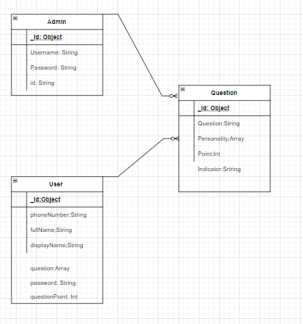

### **Detail**

* + 1. **Admin**

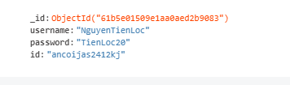

|  |  |  |  |  |
| --- | --- | --- | --- | --- |
| **Attributes** | **Datatype** | **Null** | **Description** | **Extra** |
| _id | objectId | Not | Id of one record admin data |  |
| username | String | not | Login name |  |
| password | String | Not | Login passwords |  |
| id | String | not | ID of admin |  |

* + 1. **Users**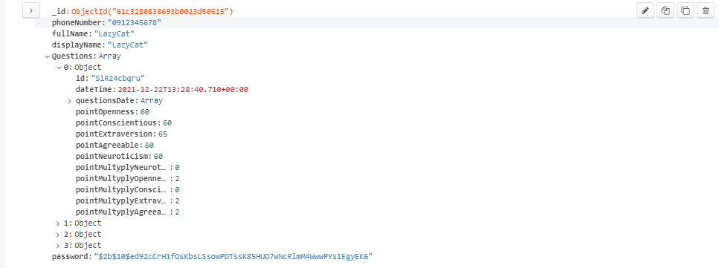

|  |  |  |  |  |
| --- | --- | --- | --- | --- |
| **Attributes** | **Datatype** | **Null** | **Description** | **Extra** |
| _id | objectID | Not | Id of one record a user data |  |
| phoneNumber | String | Not | Phone number of a user |  |
| fullName | String | Not | Full name of a user |  |
| displayName | String | not | Display name of a user |  |
| Question | Array |  | List questions that a user recieve |  |
| id | String |  | Id of a object question |  |
| dateTime | datetime |  | Datetime of a object question that user recieves |  |
| questionDate | Array |  | List of question are sent by the dashboard and by once |  |
| answer | String |  | User’s answer of a question |  |
| pointOpenness | Int |  | user’s Openness point of a object question |  |
| pointConscientious | Int |  | user’s Conscientious  point of a object question |  |
| pointExtraversion | Int |  | user’s Extraversion point of a object question |  |
| pointNeuroticism | Int |  | user’s Neuroticism  point of a object question |  |
| pointArgeeable | Int |  | user’s agreeable point of a object question |  |
| pointMultyplyOpenness | Int |  | Point multyply openness trait of a object question |  |
| pointMultyplyConscientious | Int |  | Point multyply conscientious trait of a object question question |  |
| pointMultyplyExtraversion | Int |  | Point multyply extraversion trait of a object question |  |
| pointMultyplyNeuroticism | Int |  | Point multyply neuroticism trait of a object question |  |
| pointMultyplyArgeeable | Int |  | Point multyply argeeable trait of of a object question |  |
| password | String |  | Password user’s |  |

* + 1. **Question**

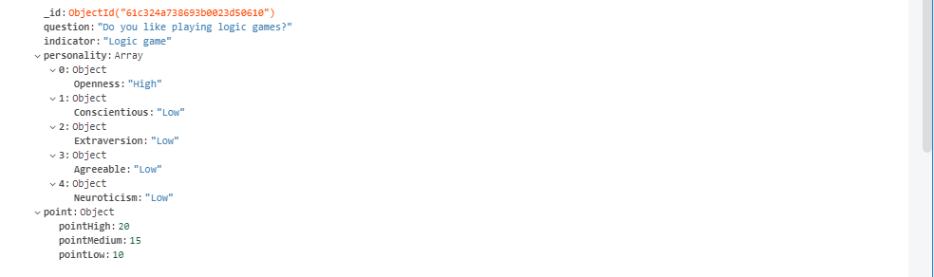

|  |  |  |  |  |
| --- | --- | --- | --- | --- |
| **Attributes** | **Datatype** | **Null** | **Description** | **Extra** |
| _id | ObjectId | not | Id of question |  |
| indicator | String | not | Indicator of question |  |
| question | String | not | Save string question of question |  |
| personality | Array | not | List personality of question |  |
| point | Object |  | The point of question |  |
| pointHigh | Int |  | The point high of question |  |
| ponitMedium | Int |  | The point medium of question |  |
| pointLow | Int |  | The point low of question |  |
| Openness | String | not | The trait opeeness of question |  |
| Conscientious | String | not | The trait conscientious of question |  |
| Extraversion | String | not | The trait extraversion of question |  |
| Agreeable | String | not | The trait agreeable of question |  |
| Neuroticism | String | not | The trait neurotticism of question |  |

# **References**

[1] [MongoDB: the application data platform | MongoDB](https://www.mongodb.com/)

[2] [diagrams.net](https://app.diagrams.net/)